*Design 1: Uniform Radius, Nlow*

\*\*\*using a 20 gauge wire\*\*\*

Circumference of Helix = 125 mm

Diameter of Helix = 39.788 mm

Lambda = 125 mm

Operating Frequency = 2.4 GHz

Pitch Angle = 13 degrees

Number of Turns = 16

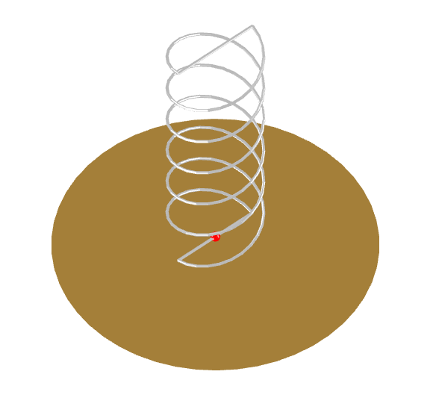

*Design 2: Uniform Radius, Nhigh*

\*\*\*using a 20 gauge wire\*\*\*

Circumference of Helix = 125 mm

Diameter of Helix = 39.788 mm

Lambda = 125 mm

Operating Frequency = 2.4 GHz

Pitch Angle = 13 degrees (11-14 optimal)

Number of Turns = 20

3D printed mandrel dimensions:

(2 of these need to be made, then joined)

Diameter: D = 38.768 mm (accounts for wire thickness)

Length: L = 200 mm (576 mm total length for 20 turn)

Spacing between turns = 28.86 mm

*Design 3: Conical Horn Reflector (using lambda/2)*

3D printed dimensions:

\*\*\*all diameters should be inner radius, no base plate attached\*\*\*

Larger Diameter = 156.25 mm

Smaller Diameter = 46.875 mm

Height of Cone = 31.25 mm

*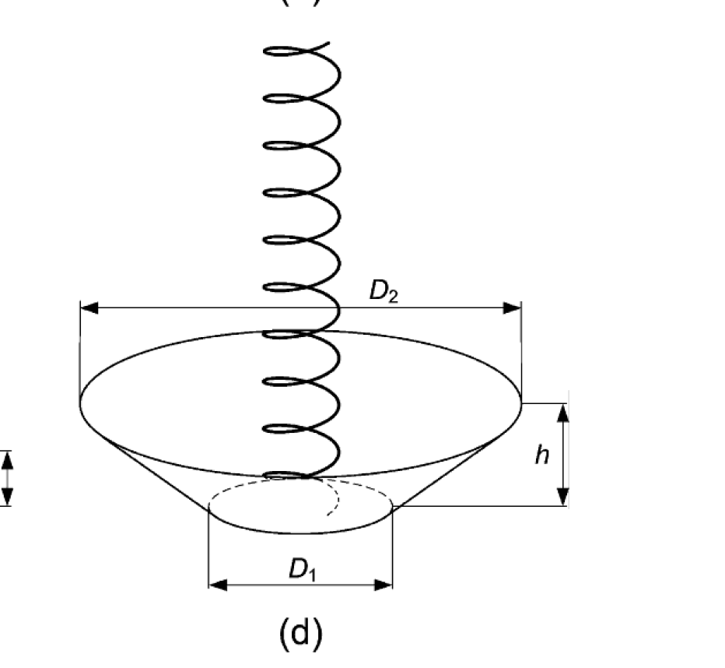*

*Design 4: Conical Horn Reflector (using lambda/4)*

Larger Diameter = 78.125 mm

Smaller Diameter = 23.437 mm

Height of Cone = 15.625 mm

**

*Design 5: Conical Horn Reflector (best fit)*

\*\*\* refer to existing structural CAD drawings for these dimensions, using only the available space between cap and end card for a non-deployable reflector design\*\*\*

Larger Diameter =

Smaller Diameter =

Height of Cone =

**

\*\*\*Wait to make the mandrels for all these tapered designs, will update dimensions soon\*\*\*

*Design 6: Four Step Tapered Spiral*

Radius 1 of Helix = 23.856 mm

Radius 2 of Helix = 21.688 mm

Radius 3 of Helix = 20.748 mm

Radius 4 of Helix = 19.894 mm

Lambda = 125 mm

Operating Frequency = 2.0 - 2.5 GHz

Number of Turns = 16

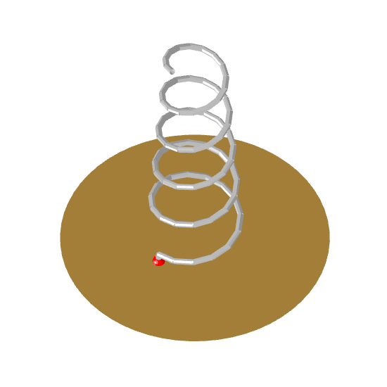

*Design 7: End Tapered Spiral*

Radius 1 of Helix = 19.894 mm

Radius 2 of Helix = 19.085 mm

Lambda = 125 mm

Operating Frequency = 2.4-2.5 GHz

Number of Turns = 16

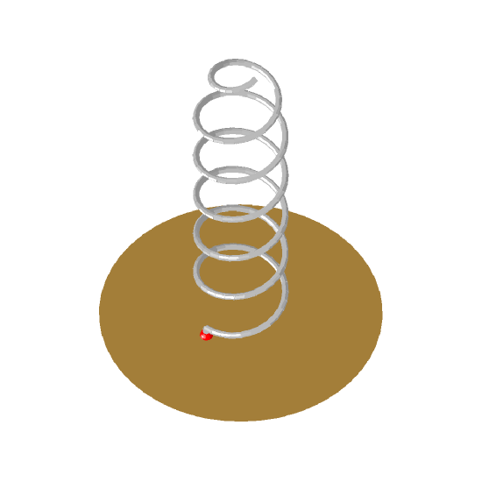

*Design 8: Continuous Tapered Conical Spiral*

Radius 1 of Helix = 19.894 mm

Radius 2 of Helix = 23.856 mm

Lambda = 125 mm

Operating Frequency = 2.0-2.5 GHz

Number of Turns = 16

